Name:  Teacher: | ____________________________________  ________________ |  | Date:_________
 | Year 9 Mathematics  SCORE:  / 20  Mini test 5  Topic – Quadratic Equations  Full working out MUST be shown to get full marks for each question.
Total Time: | 30 minutes
Weighting: | 5 %
Equipment: | To be provided by the student: Pens and Pencils, scientific calculator, A4 page of notes.

Multiple Choice Section 5 marks

Questions 1 – 3 refer to the graph below:
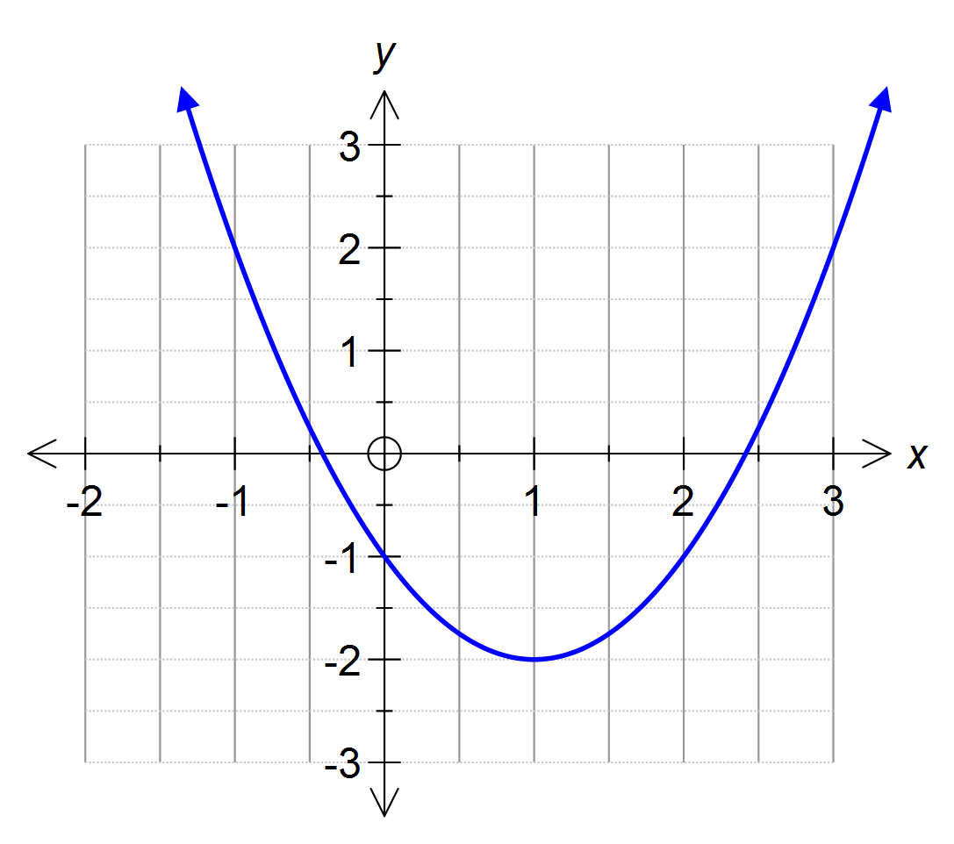

1 The equation of the axis of symmetry for this graph is:

A x = 1 B x = –2 C y = 1 D y = –2 E y = –1

2 The turning point of the graph is:

A a minimum at (–2, 1) B a maximum at (–2, 1)

C a minimum at (1, –2) D a maximum at (1, –2)

E a minimum at (–1, 2)

3 The equation of the graph is:

A y = (x + 1)² – 2 B y = (x – 1)² + 2 C y = (x – 2)² + 1

D y = (x – 1)² – 2 E y = (x + 1)² + 2

4 The transformation of the graph y = x² to y = x² + 2 is described by:

A a translation of 2 units left B a translation of 2 units up

C a translation of 2 units right D a translation of 2 units down

E a translation of 2 units right and 2 units down

5 Compared to y = x², the narrowest graph is:

A y = 2.5x² B y = C y = 5x²

D y = 25x² E y = 0.5x²

Short Answer Section 15 marks

1 [11 marks: 7, 4]
For the quadratic equation y = x² + 2x – 8.

a Create a table of values with x-values from -3 to 3

b Using your table of values, construct the graph of the parabola including all major features.

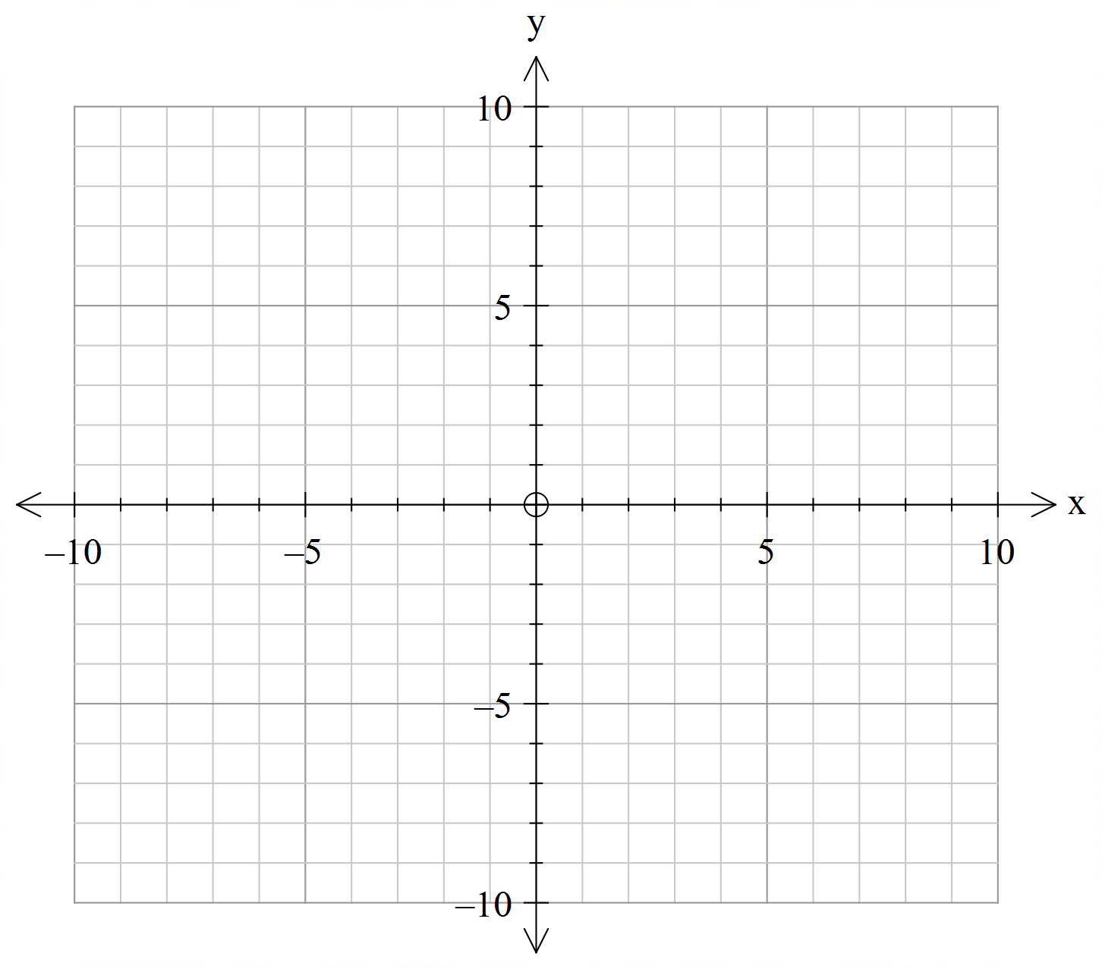

2 [4 marks: 1, 1, 2]
Sketch the graphs of these rules showing the coordinates of the turning point and the y-intercept.

a y = (x – 3)² b y = –x² + 2

___________________________ ___________________________

___________________________ ___________________________

___________________________ ___________________________

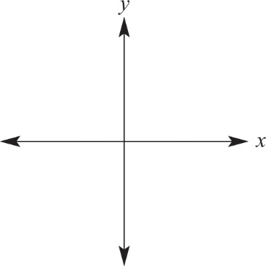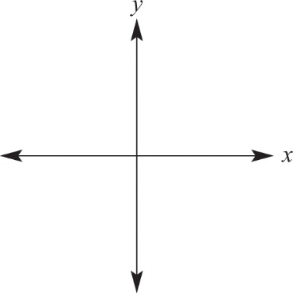

c y = (x + 1)² – 2

___________________________

___________________________

___________________________

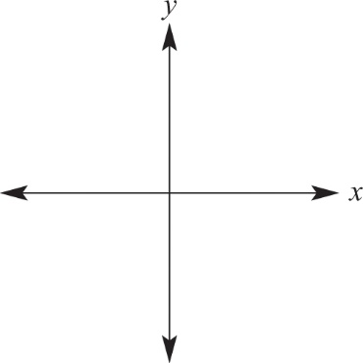

3 [5 marks: 2, 2, 1]
Sketch the graphs of these rules showing the coordinates of the turning point and the y-intercept.
a Complete the following table of values for $y=2^{x}.$

$$x$$ | -3 | -2 | -1 | 0 | 1 | 2 | 3
$$y$$

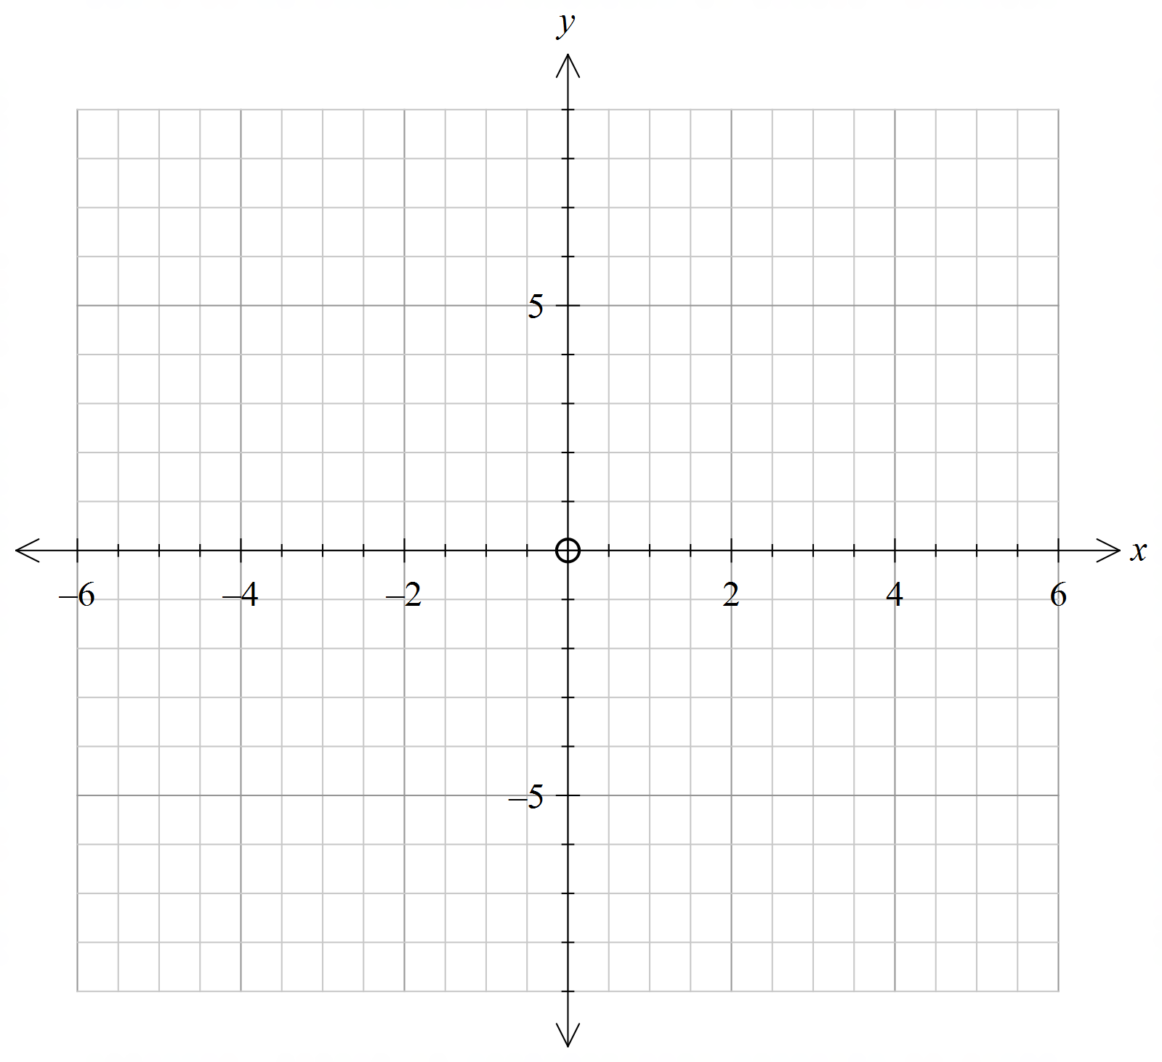 b Draw the graph of $y=2^{x}.$

c Clearly label the y-intercept of $y=2^{x}.$

